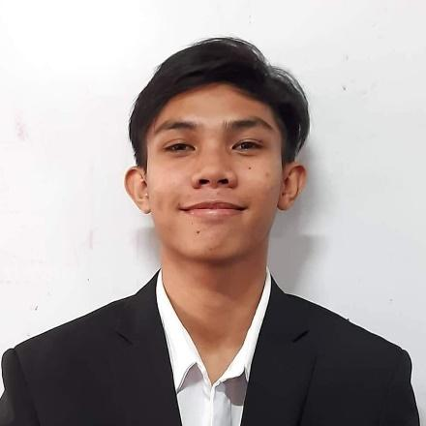
SA’AD BIN AIN M. JANDUL
Block 3 Lot 8 Phase 1 Executive Blue homes Lower Cabatangan, Pasonanca , Zamboanga City
Contact No.: 09472063142
Email: jandulsaad@gmail.com
OBJECTIVES:
To immerse in a company where I can enhance my skills and gain a knowledge as an ICT student
EDUCATIONAL BACKGROUND:
2019 – 2021 Senior High School
Taguig National High School
A Reyes St., New Lower Bicutan, Taguig City
(Information Communication and Technology)
2015 – 2019 Junior High School
Taguig National High School
A Reyes St., New Lower Bicutan, Taguig City
2009 – 2015 Elementary
Maharlika Elementary School
Taguig, 1630 Metro Manila
SEMINARS ATTENDED:
Project READY – (Resistance Education Against Drugs for the Youth)
DevFest – ( Google Developer Groups (GDG) around the globe. It brings together developers, tech enthusiasts, and innovators for a day of learning, networking, and hands-on experience with the latest Google technologies)
SKILLS:
- Cooperative
- Multi-Tasking
- Python
- Html/CSS
- Django
- Mysql
- Php
- Figma
CHARACTER REFERENCES:
MRS. MAUREEN E. MEDES Teacher Taguig National High School 09198861623
MR. PEDRO ALBITO Teacher Taguig National High School 09193374251
MRS. VIVIAN MAE G. SORIOSO Shift Manager McDonald’s BGC Forum 09275859049

I hereby declared that the information above is true.
SA’AD BIN AIN M. JANDUL Signature over printed name

